ST MATTHEW’S CATHOLIC PRIMARY SCHOOL

I would like to order the following items:

Child’s Name: ____________________________________________________________________

Class: ____________________________________ Date: _________________________

Please check you are ordering the correct size. | 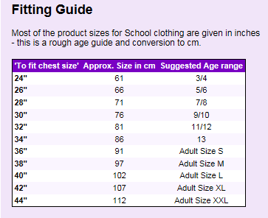

 |  |  | Size | Price | Quantity | Amount
Sweatshirt | sizes 24”/26”/28”/30”/32”  sizes 34”/S/M/L | £9.00  £10.00
Cardigans | sizes 24”/26”/28”/30”/32”  sizes 34”/S/M/L | £10.00  £11.00
Polo Shirt | sizes 24”/26”/28”/30”/32”  sizes 34”/S/M/L | £8.00  £9.00
PLEASE REMEMBER TO CHOOSE THE SIZE |  |  | TOTAL AMOUNT

I enclose cash totalling £__________________

For office use only

Signed: ……………………………………….………………… Dated: …………………………….

Received with thanks the sum of £……..…………cash

